- Screenshot Folder Tugas-13
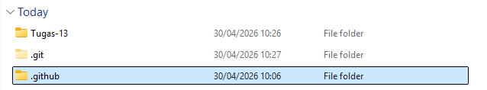

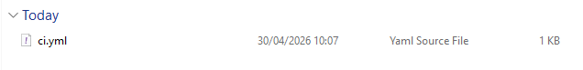
- Screenshot File YAML
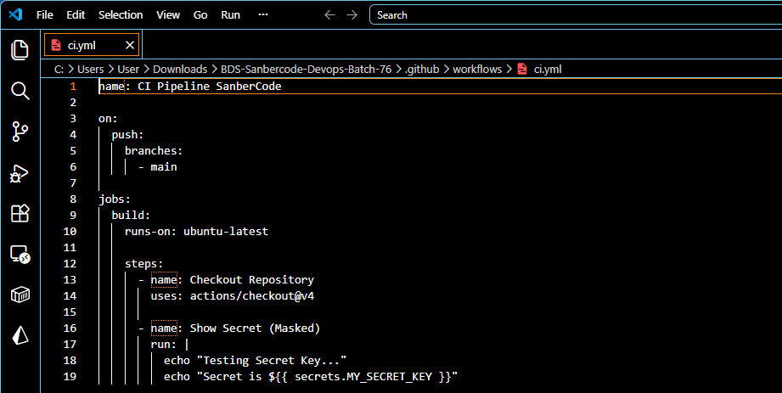

- Screenshot Pipeline Success
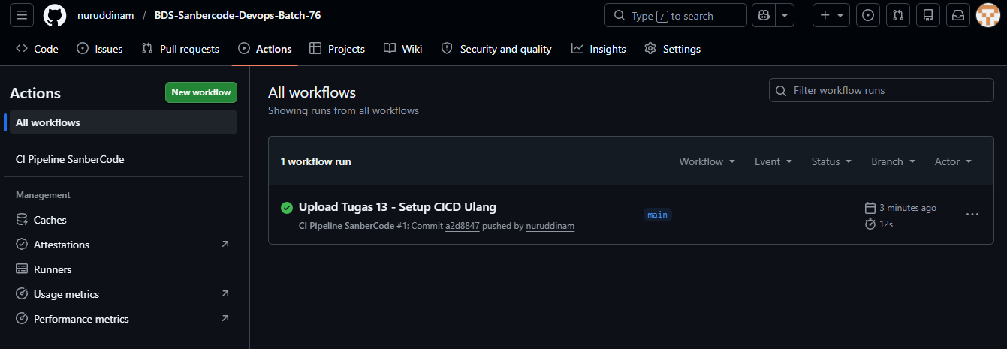

- Screenshot Log Execution (PALING PENTING)
